**Blood Bank Application**

**Blood Bank Application** is a simple application to manage blood transfusion. Your task is to develop this application in **C Programming Language** based on below requirements. This application has 4 main menus:

1. **View Data (Sorted by Donor Name)**
2. **Insert New Data**
3. **Request Blood Transfusion**
4. **Save Data and Exit Application**

Every **record** of data consist of: **Donor Name, Blood Type, and Availability**. This data are **stored** in **“data.dat”** file. **You are allowed** to use **struct data type**.

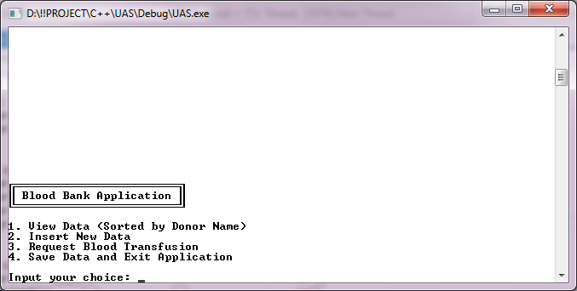

**Figure 1. Home screen of Blood Bank Application**

1. **Menu 1 : View Data (Sorted by Donor Name)**

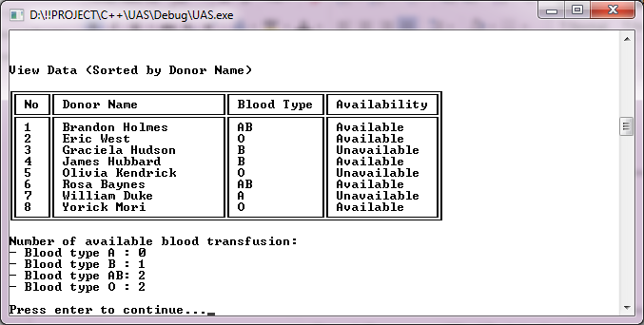

**Figure 2. Preview of Menu 1**

* Display all data stored in the application
* Blood data will be **read** from **“data.dat”** file
* Data shown has been **sorted by donor name (ascending)**
* Display the **number of available blood for each type**

1. **Menu 2: Insert New Data**

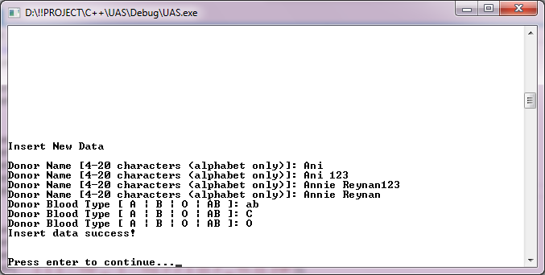

**Figure 3. Preview of Menu 2**

* Requirement for **Donor Name**:

1. Only **alphabet (A-Z and a-z)** and **blank spaces allowed**
2. **4 – 20 characters**

* **Available choice** for **Blood type** are (**case sensitive**):

1. **“A”**
2. **“B”**
3. **“AB”**
4. **“O”**

* Every **new data** will have their **Availability set to “Available”**

1. **Menu 3: Request Blood Transfusion**

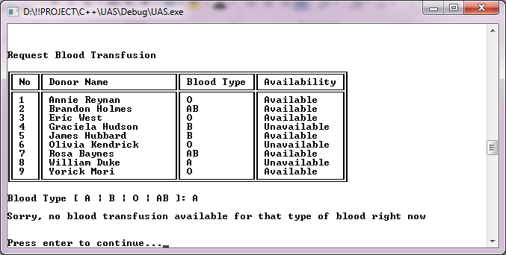

**Figure 4. Preview of Menu 3 (Unavailable Request)**

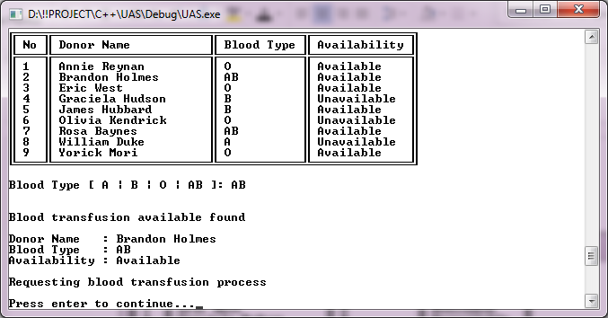

**Figure 5. Preview of Menu 3 (Available Request)**

* **Display** all data **stored** in the application
* **Input choice** for **Blood type** (**case sensitive**)
* **Search** for **the first** blood data which match **Blood Type input and** has **Availabily** status **“Available”**
* If **there is no blood data match the criteria** then show the unavailability message
* If **there is a blood data match the criteria** then:
* **Display** the blood data
* **Update** the **selected blood data Availability** to **“Unavailable”**

1. **Save Data and Exit Application**

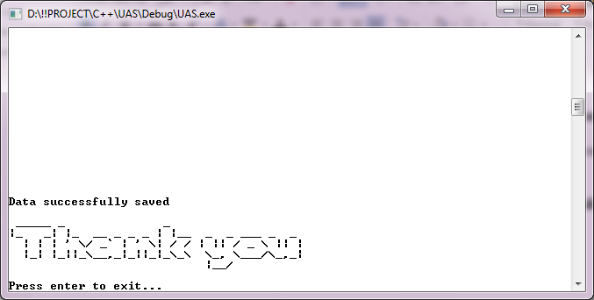

**Figure 6. Preview of Menu 4**

* **Store all blood data** in the application to **“data.dat” file using below format:**

**Donor Name#Blood Type#Availability**

***(Please open “data.dat” file using Notepad Program for further example of the file writing format)***

* Display thank you message
* Exit the application